Lab – 7

Ultrasonic Sensor Interfacing

1. Aim
To measure distance using an ultrasonic sensor interfaced with Arduino.

2. Theory
HC-SR04 measures distance using ultrasonic sound waves.
Working principle:
- Sensor sends ultrasonic pulse
- Pulse reflects from object
- Echo time is measured
- Distance calculated using sound speed
Distance formula:
$$Distance=\frac{Speed×Time}{2}$$

3. Apparatus / Requirements
- Arduino Uno
- HC-SR04
- Breadboard
- Jumper wires

4. Circuit Diagram
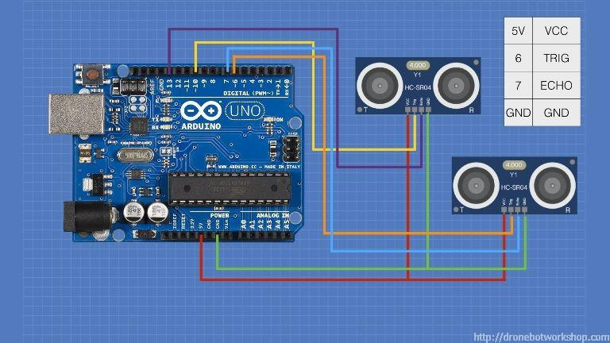
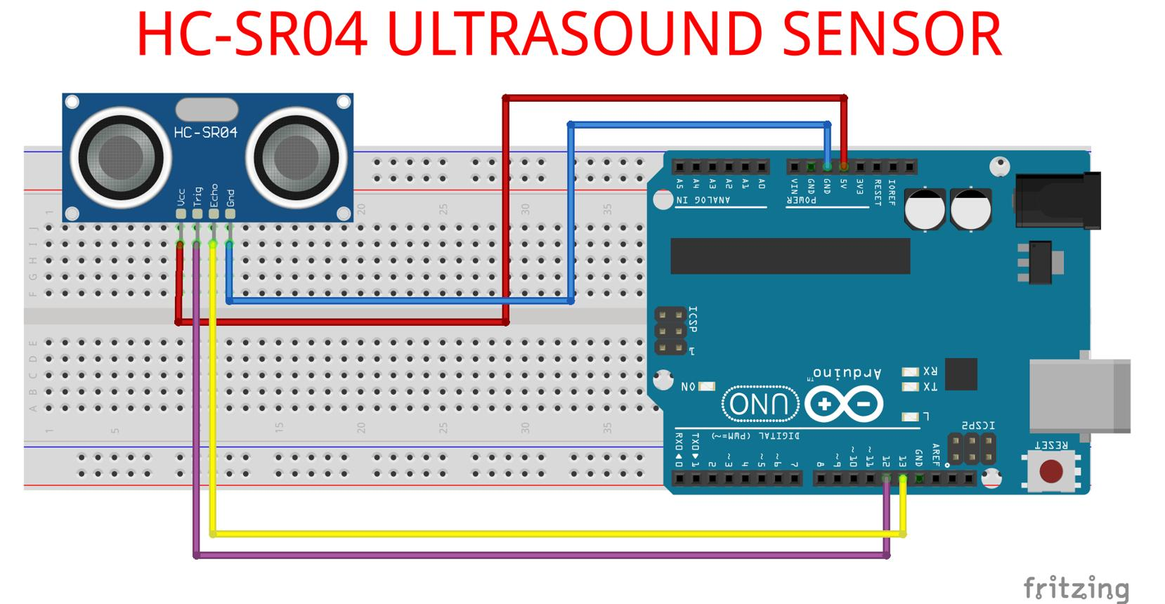
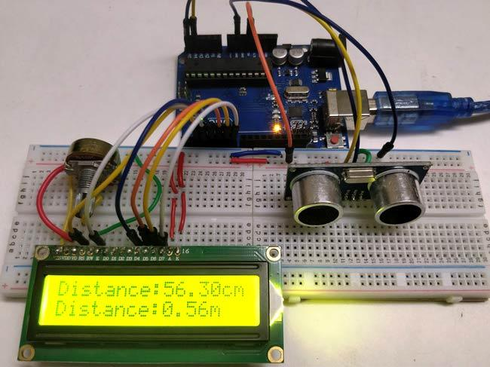

5. Procedure
- Connect HC-SR04 to Arduino
- Connect trigger and echo pins
- Write Arduino code
- Upload program
- Open Serial Monitor
- Place object in front of sensor
- Observe measured distance

6. Program / Code

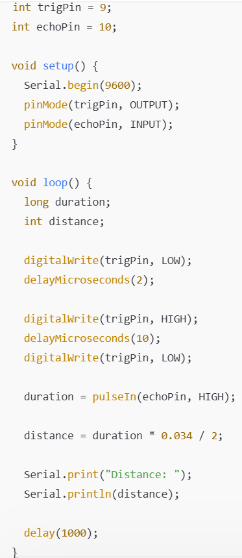

7. Observations / Readings
Object Distance | Sensor Reading
- 10 cm | - 10 cm
- 20 cm | - 21 cm

8. Result
Distance measurement using the ultrasonic sensor was successfully performed.

